**Sister A’s Rolling Rapids**

**Site Plan**

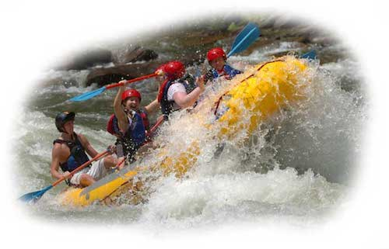

Trish Adelsperger

WDD100-section 01

**Overview**

Site Purpose

At Sister A’s Rolling Rapids, we want to portray that we are the best at what we do, which is delivering supreme rafting adventure experiences. Also that an unforgettable trip with us will be a thrill of a lifetime, and that rafting is for (almost) all ages. Singles, families, groups of friends, work retreats, we serve them all.

We want a clear description of the packages we offer, easy to find custom package contact information, clearly seen and easily added ancillary goods and services. We want our clients to be able to schedule their trip, add upsell items, sign waivers, and pay for it all in one sitting.

The goal is that the result of doing these things will increase our revenue and exposure, and lead to a reputation of a premiere recreation destination.

Target Audience

Our target audience is middle to upper class singles and families, as well as businesspersons and companies looking for incentive/reward/teambuilding retreat experiences. Our clientele are anywhere from weekend warrior to thrill-seeker, with active to semi-active lifestyles.

These people are looking for a place to bond with others, a place to challenge themselves through activity, a place to unplug and reconnect with nature. A place to get away from the daily fast-paced grind of work, all in one package.

They need time to de-stress. They need time with their loved ones. They need a timeout from life. They need a fast way to reserve time for recreation.

Laptops and phones are probably the most popular way to see our site with the clientele we want to attract. They are on the run most of the time, and mostly use their wireless devices and laptops to access the internet.

**Branding**

Website Logo



**Color Palette**

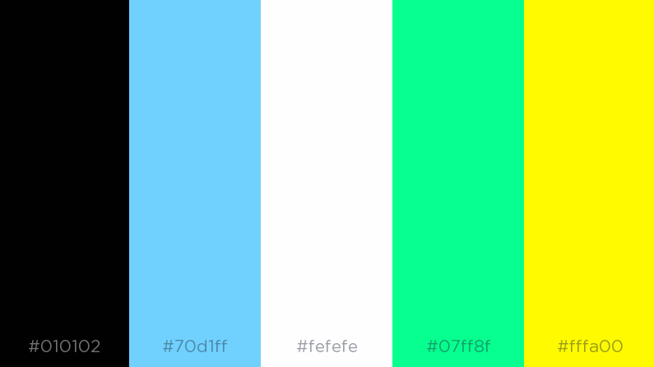

|  |  |  |  |  |
| --- | --- | --- | --- | --- |
| **Primary** | **Secondary** | **Accent** | **Accent** | **Accent** |
| #010102 | #70D1FF | #FEFEFE | #07FF8F | #FFFA00 |

**Typography**

Heading and Paragraph Fonts

**Headline Font-family: Bradley Hand, color: #70D1FF**,  **#FEFEFE or #010102 (blue, white or black), 26px, style: italic**

**<h1>The Whitewater Rafting Company<h1>**

**<h1>The Whitewater Rafting Company</h1>**

**<h1>The Whitewater Rafting Company<h1>**

**Font-family: Papyrus, color: #70D1FF,**  **#FEFEFE or #010102 (blue, white or black), 18px**

**<p>The best Whitewater Rafting in Colorado, White Water Rafting Company offers rafting on the Colorado and Roaring Fork Rivers in Glenwood Springs. Since 1974, we have been family owned and operated, rafting the Shoshone section of Glenwood Canyon and beyond. </p>**

**<p>Trips vary from mild and great for families, to trips exclusively for physically fit and experienced rafters. No matter what type of river adventures you are seeking, White Water Rafting Company can make it happen for you. We strive to make your fart trip the very best of your life. We pride ourselves on our 5-Star rating with Trip Advisor and our many other awards and accolades. </p>**

**<p>We are conveniently located an hour or less from Aspen, Snowmass, Eagle Avon, Beaver Creek, Vail, and Grand Junction.</p>**

**Navigation**

Main Navigation

|  |  |  |
| --- | --- | --- |
| Home | Rivers and Rates | About Us |

Links

Link:normal : #FEFEFE

Link:hover : #010102

**Layout**

Site Map

**Home**

**Rivers and Rates**

**About Us**

**Wireframes**

Wireframes are like blueprints for making webpages. They should show the major sections of content that will be on the page and the relative locations of each element. In the basic wireframe below you can see there will be 6 sections to our page:

At the top we have a section with the logo (the box with the mountain means an image) and the navigation bar. Then there is a banner image that stretches all the way across the screen. Next we have some text and an image followed by an image and some text. Then one more section of text with no image. Lastly, a footer containing a copyright/name line and the 3 sociamedia icons you will use for your website.

Wireframes optionally can also contain information about element sizes as this one does. The 115x100 on the logo placeholder is telling you that it should be 115px x 100 px. The px stands for pixels…a common unit of measurement on the web.

